Good hand hygiene
Avoid getting infected and infecting other

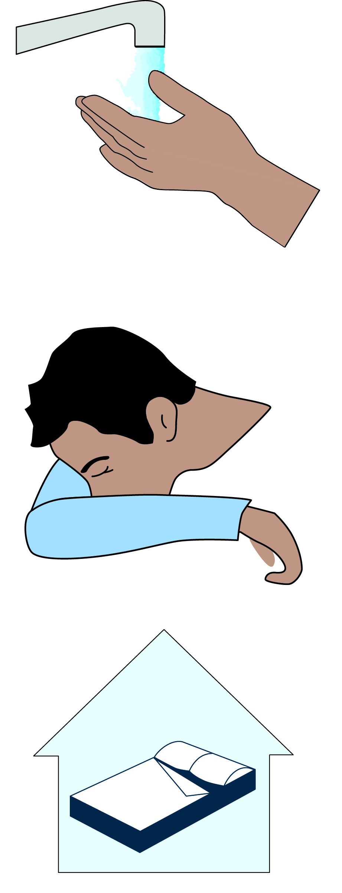

Wash your hands often!
Infectious substances stick easily to hands and other surfaces such as door handles. They are then passed on when you touch someone with your hands. So wash your hands often with soap and hot water. Always wash your hands before meals, when handling food and after a toilet visit. A hand gel can be an alternative when you are not able to wash your hands.

Cough and sneeze in the bend of your arm!
When you cough and sneeze, small, small drops containing infectious substances are spread. By coughing and sneezing in the bend of your arm or in paper hankie, you prevent infection spreading around you or contaminating your hands.

